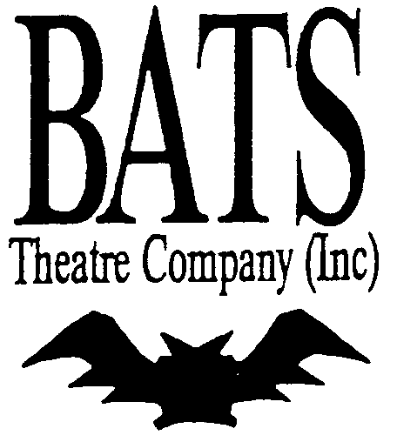

MEMBERSHIP FORM for YEAR ENDING 31ST DECEMBER 2025

POST OFFICE BOX 223, BUDERIM, QLD. 4556
Membership Officer: Phone: 0457 438 236 Email reaolive@gmail.com
Website: www.batstheatre.com

APPLICATION FOR MEMBERSHIP/RENEWAL (Please print clearly)

NAME (First) …………………………………………… SURNAME ……………………………………………………….

ADDRESS:………………………………………....................................................SUBURB:......................................P/code..........

Phone ...............:............................................................. Mobile/Work No …………………………………..................................

Email address: ...........................................................................................................................................................................................

TYPE OF MEMBERSHIP: (Please tick✓) FAMILY $25.00 SINGLE $10 YOUTH $10

For Family Members (Please include any children with a different surname)
……………………………………………………………………………………………………………………………………………
……………………………………………………………………………………………………………………………………………
……………………………………………………………………………………………………………………………………………
All Membership fees are valid for year to 31st December, 2025.

All cheques to be made payable to BATS Theatre Company Inc.
*Direct Debit Details: Account Name: BATS Theatre Company Inc.
Bank: Bank of Queensland/BSB No: 124 081/Account No: 11510325
If paying by direct debit, please indicate date of payment here: ……………………………………………...

Please tick () all your areas of interest:

ACTING BACKSTAGE
SET CONSTRUCTION STAGE MANAGING
LIGHTING AND SOUND MAKEUP & HAIR DESIGN
FRONT OF HOUSE SCRIPT WRITERS
DIRECTING WARDROBE
MUSIC PUBLICITY
SINGING DANCING

Please list any experience in performing or visual arts: ....………………………………………………………
………………………………………………………………………………………………………………………………………………………………………………………………………………………………………………………………………………………………………………………………………………………………………………………………………………………………………………………………………………………………………………………………………………………………………………………………………………………………………………………………………………………………………………………………
I hereby declare that I ………………………………...............................have completed this membership form

SIGNED: …………………………………………………….DATE:…………………………………………..

BATS Theatre Company (Inc.) reserves the right to refuse or cancel any membership
For office use only: Payment Received Date:….………Amount:….……Direct Debit.  Cheque Money Order Cash  ()
Approved Membership Date: ………………………………………Added to Membership List:……………………………………....................
Sent confirmation & Membership Card: Date…………………………Membership Number:……………………………………………………...

